**Project Design Phase-II**

**Data Flow Diagram & User Stories**

|  |  |
| --- | --- |
| Date | 28 June 2025 |
| Team ID | LTVIP2025TMID55291 |
| Project Name | **FreelanceFinder: Discovering Opportunities, Unlocking Potential** |
| Maximum Marks | 4 Marks |

**Data Flow Diagrams:**

A Data Flow Diagram (DFD) is a traditional visual representation of the information flows within a system. A neat and clear DFD can depict the right amount of the system requirement graphically. It shows how data enters and leaves the system, what changes the information, and where data is stored.

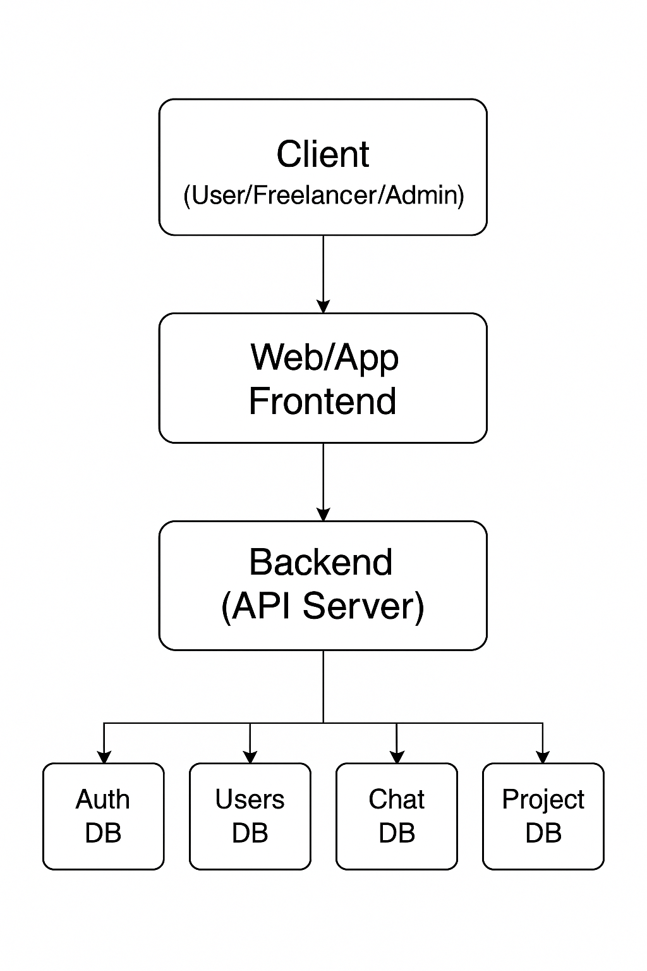+



**User Stories**

Use the below template to list all the user stories for the product.

| **User Type** | **Functional Requirement (Epic)** | **User Story Number** | **User Story / Task** | **Acceptance criteria** | **Priority** | **Release** |
| --- | --- | --- | --- | --- | --- | --- |
| Customer (Mobile user) | Registration | USN-1 | As a user, I can register for the application by entering my email, password, and confirming my password. | I can access my account / dashboard | High | Sprint-1 |
| user | Login | USN-2 | As a user, I can log into the application by entering email & password | I can successfully log in and access the dashboard | High | Sprint-1 |
| Customer (Web user) | Profile Management | USN-3 | As a user, I can update my profile, add skills, and upload a portfolio | Updated info reflects on profile | Medium | Sprint-2 |
| Customer Care Executive | User Support | USN-4 | As support staff, I can respond to queries and issues through an admin interface | Users receive timely responses | Medium | Sprint-3 |
| Administrator | User Monitoring | USN-5 | As an admin, I can view all user accounts, flagged content, and take action | I can deactivate or flag users if needed | High | Sprint-3 |
| Admin | Dashboard Analytics | USN-6 | As an admin, I can view charts of active users, project stats, and revenue trends | Analytics are visible and filterable | Medium | Sprint-3 |